# *Title* PAR - Convert Public Accountability Report into a Web Report-SR 18090

Approved ____________________

Date _________________

# *Functional Overview.*

The development team will rewrite the reporting mechanism for PAR to make it web based on the IOC website (illinoiscomptroller.gov).

Reference to PAR Fiscal Year 2017, Link: <https://illinoiscomptroller.gov/financial-data/find-a-report/public-accountability-report/fiscal-year-2017/>

1. PAR will become an online report:
   * The report will allow the user to filter information by Fiscal Year, Program Area, Agency, and Program Name. The user will be able to drill down data by selecting an option from a drop-down menu.
   * The user will be able to retrieve data dating back to Fiscal Year 2002.
   * It is important to select a Fiscal Year and Program Area first in order to get options in the drop-down for an Agency and a Program Name.
     1. The data retrieved will display a table with results describing the:
        + Agency’s Narrative
        + Mission Statement
        + Program Goals
        + Program Objectives
        + Source of Funds
        + Input Indicators
        + Output Indicators
        + Outcome Indicators
        + Outcome Indicators External Benchmarks
        + Efficiency/Cost Effectiveness Indicators
        + Efficiency/Cost Effectiveness Indicators External Benchmarks
        + Explanatory Information
        + Footnotes
     2. The results will also display numeric data for Fiscal Year Actual and Fiscal Year Target/Projected to the columns above and to the Fiscal Year that was selected previously.
        + It is important to keep in mind that the numeric data will display columns with (4) Fiscal Years that depend on the Fiscal Year that was previously selected by the user through the drop-down list.
   * Archived reports in PDF form will remain available online, from years 1999-2018 in which they will be printer friendly.
   * The reports will be printer friendly in a PDF format, and data can also be exported.
2. The web application will give the reader a much cleaner, interactive, and user-friendly experience when viewing the report online.
3. The web application report should include graphs, legends and other visuals.
4. The web application will display the same information that is currently presented in the PAR PDF Report that is manually created.
5. The data is entered by agencies and it is currently stored in an SQL database that is queried and developed in Access to create the PAR report in a prescribed format.
   * As it is currently done, the data in the web application should match the data that is pulled from the Warehouse

### Requirements for the landing page: Mirror the PDF compiled by Stephanie Blair (PAR-FY 2017).

## Introduction

1. Short paragraph from the actual letter written by the Comptroller.
   * The full letter should be available by a *Show More button*, and there is an option to hide this section by clicking a *Hide button*.
   * Every year, the Comptroller’s letter should be stored, and available to be retrieved by users.

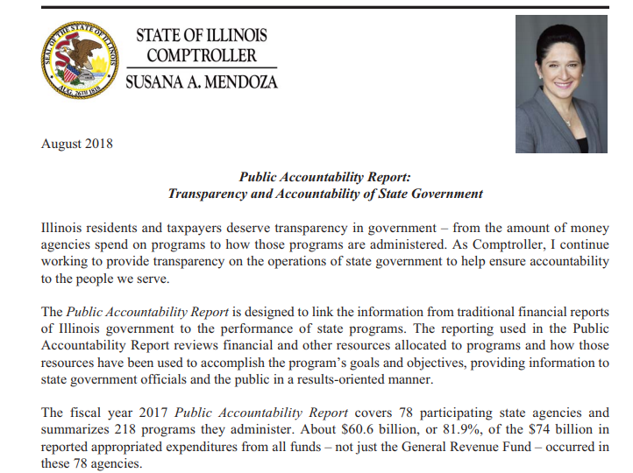

* The PAR Introduction will be expandable.
  + The user should view the Introduction section explaining the PAR report and its purpose (p. 1, PAR FY2017). The introduction will also display a small paragraph that can be expanded by a *Show More button*, and there is an option to hide this section by clicking a *Hide button*.

The Introductions entails:

* + - The Goals of Public Accountability
    - Make state government more results-oriented.
    - Increase public awareness of the success of state government programs.
    - Facilitate informed decision-making on the allocation of state resources.
    - Increase public accessibility to information on state government program.

1. The drop-down menu should be under the introduction for the user to choose a Fiscal Year, Program Area, Agency, and Program Name.

* **non-reporting programs and agencies will not display on the drop-down menu, but they will be on the results. However, their link will be idle.**

**Homepage Mock-Up:**

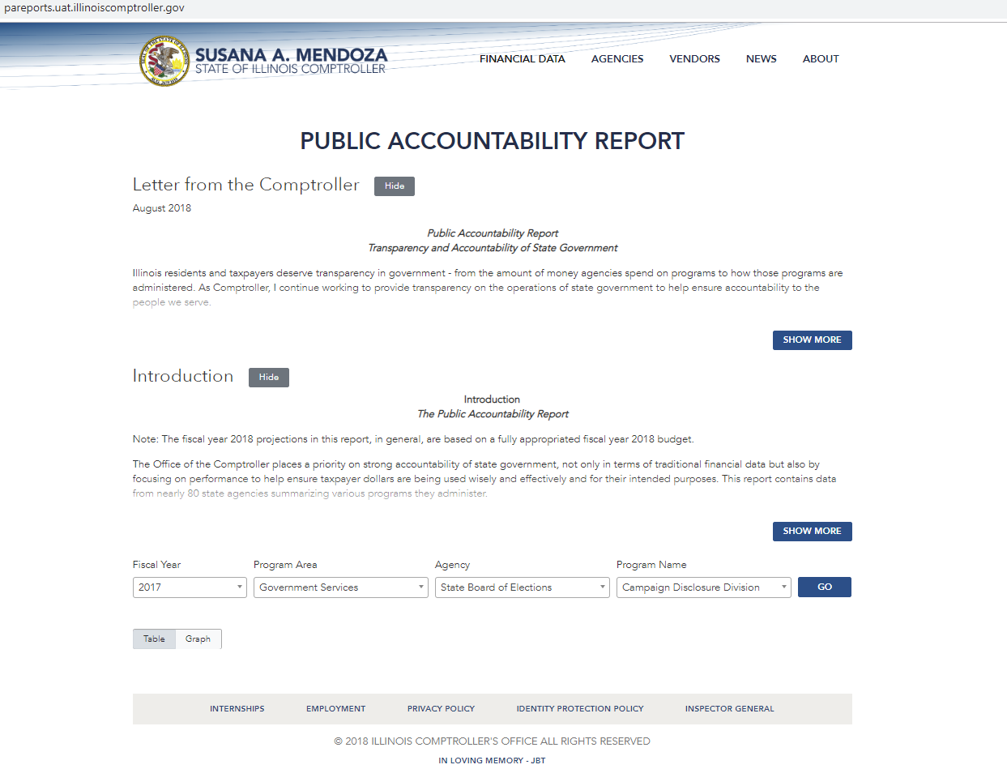

Figure 1. Home Page PAR.

2a. To make the search experience more user friendly, the user will see a symbol like this: Image result for question mark symbol to explain

This symbol serves as a help tool for the user; A description will explain the logic behind the searches and the options from the drop-down menu.

1. When a user selects a specific Fiscal Year, Program Area, Agency and Program Name, the results will be displayed by clicking the *Go button*. 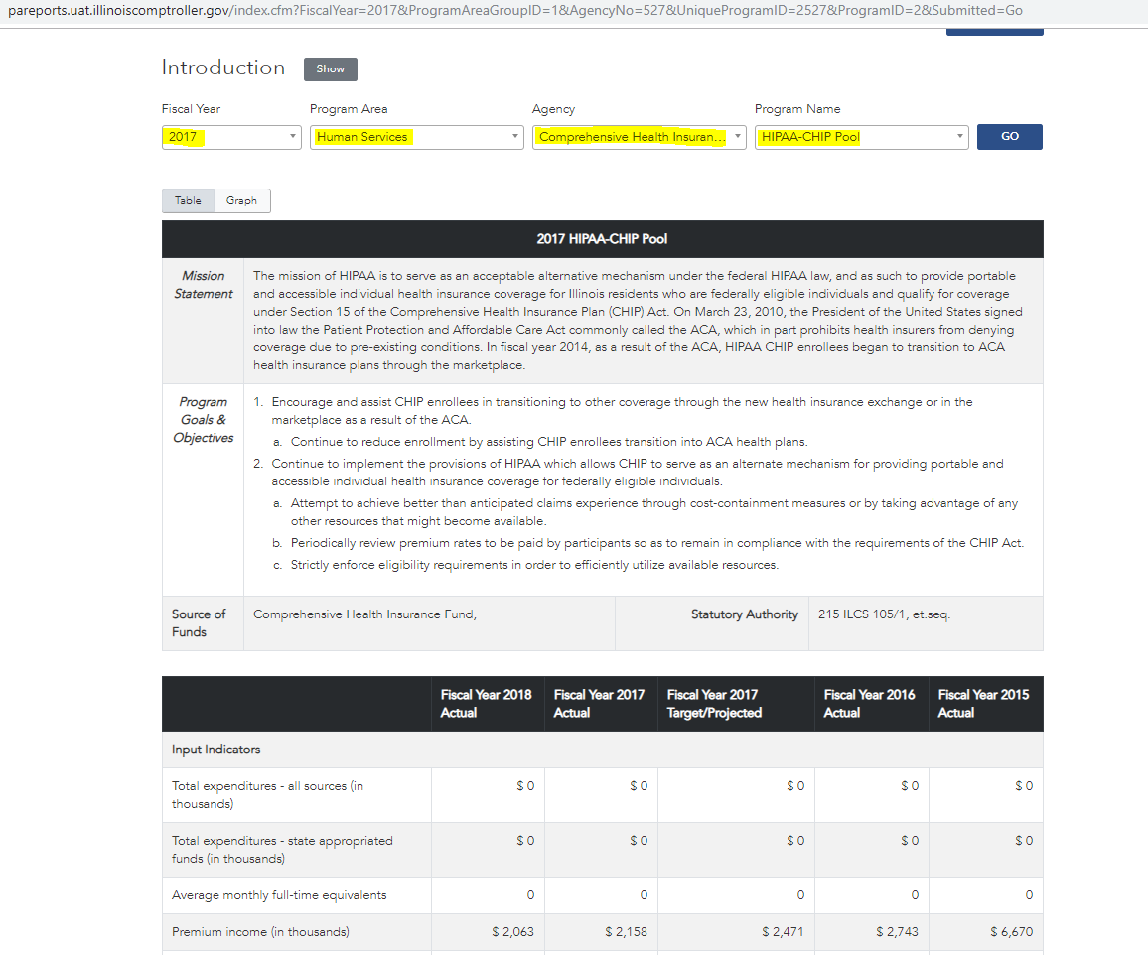*.*

Figure 2. Results Table.

3.a There should be a visual to portray the difference between Fiscal Years and the six Program Areas.

* Two pie graphs will display the comparison between the two years.

For example:

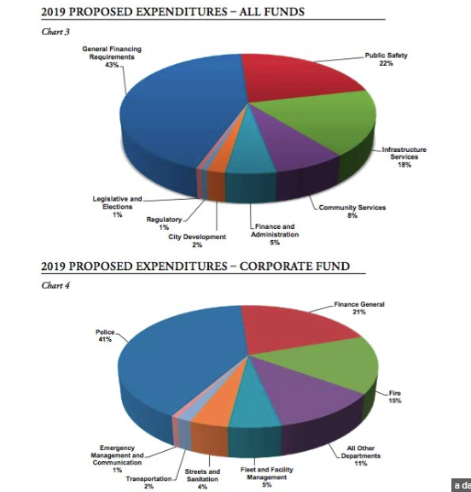

3b. In addition, Bar Charts should display for Program Area Expenditures (p. 4 in the PAR PDF)

For example:

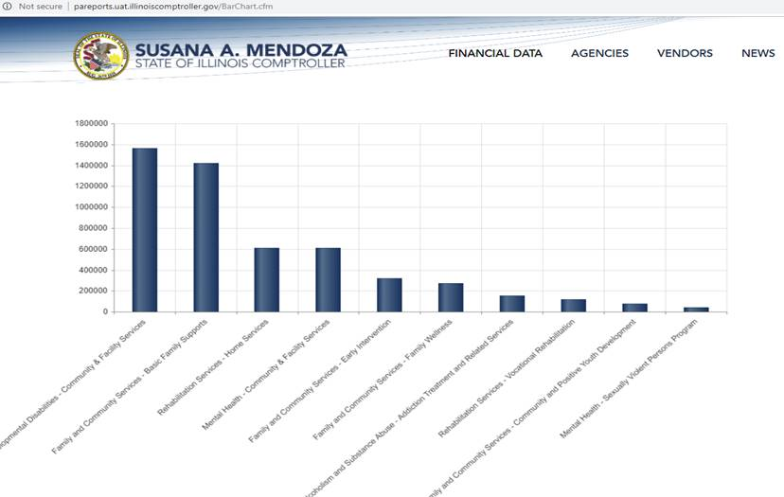

\****Text wrapped****\**.

1. Hover Over: When one hovers over certain words, a text box should display the definition of that term. The following terms should have a hover over box. The term’s definition can be found on the PAR Report PDFs of any Fiscal Year.

|  |  |
| --- | --- |
| Indicator | Definition |
| Agency Narrative | Giving a brief description of the agency and program. |
| Mission Statement | The purpose of the program. |
| Program Goals | Broad statements of the overall outcomes that the program is designed to accomplish. |
| Program Objectives | Provide measurable targets describing the results that the program is expected to accomplish during the fiscal year. |
| Source of Funds | It includes the Fund Name and the Statuary Authority. |
| Input Indicators | Measure the “effort” put into the program, usually measured by actual expenditures and staffing. |
| Output Indicators | Activity measures, generally presenting the number of items or services produced. |
| Outcome Indicators | Measures of how well the program has addressed the stated goals; in other words, the program’s accomplishments. |
| Outcome Indicators External Benchmarks | Comparisons to similar programs in other states (or a national/regional average or ranking). |
| Efficiency/Cost Effectiveness Indicators | Measures of costs per unit of outputs or outcomes. |
| Efficiency/Cost Effectiveness Indicators External Benchmarks | Comparisons to similar programs in other states (or a national/regional average or ranking). |
| Explanatory Information | Provides a descriptive explanation of expenditures and the programs. |
| Footnotes | Further details for the data table. |

* + An expanding symbol option should display for additional data.

## Step-By-Step of drilling down data:



Extraction of Data

# *Software Modifications/Program Overview*

***General Programming Instructions***

*This section describes in detail the technical solutions for building the expected results for the creation or update of screens/tables/reports/logic changes.*

***Objects to be Modified***

## Public Accountability Report Preface

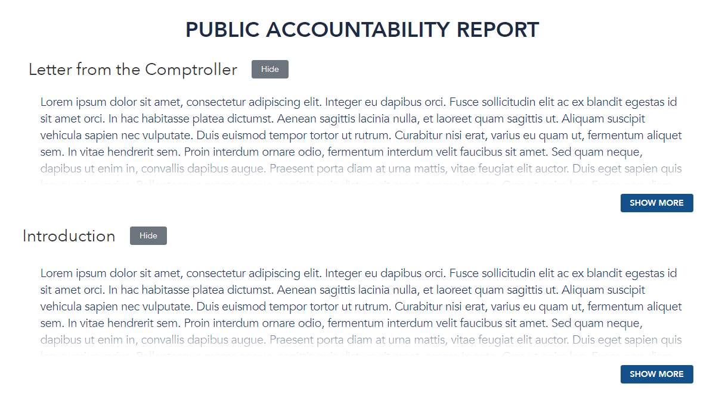

|  |  |
| --- | --- |
| **Object Name/Title** | *Public Accountability Report Preface* |
| **Object Type** | *ColdFusion CFM* |
| **New/Update** | *New* |
| **Inputs** | *N/A* |
| **Outputs** | coverLetter.html and Introduction.html |
| **Stored Procedures Called** | N/A |
| **Web Components Used** | index.cfm |
| **Front End Components Used** | N/A |
| **Selection Criteria** | N/A |
| **Program Changes** | *N/A* |
| **Program/Screen Description** | *This section of the Public Accountability Report Page will display automatically upon arriving at this screen.* |
| **Business Rule** | *On default, the Letter from the Comptroller and the Introduction will display partial content. The user can select to Hide the paragraphs or continue to read the entire Letter or Introduction by selecting ‘Show More’. If the user hides the paragraphs, the user’s preference is saved until the user’s session ends.* |
| **Comments** | *The content displayed in this section will only display the most recent PAR report’s information for the Letter from the Comptroller and Introduction.* |

## Program Accountability Report Form

|  |  |
| --- | --- |
| **Object Name/Title** | *Public Accountability Report Form* |
| **Object Type** | *Coldfusion CFM* |
| **New/Update** | *New* |
| **Inputs** | *Fiscal Year*  *Program Area (Program Area Group)*  *Agency*  *Program Name* |
| **Outputs** | Fiscal Year, Program Area Group, Agency, or Program PAR Report display dynamically dependent on user selection. |
| **Stored Procedures Called** | N/A – queries within DropDownMenu.cfc retrieves data for the drop down menu. |
| **Web Components Used** | index.cfm  DropDownMenu.cfc |
| **Front End Components Used** |  |
| **Selection Criteria** | Fiscal Year, Program Area Group, Agency, & Program |
| **Program Changes** | *N/A* |
| **Program/Screen Description** | *This program/screen will allow the user to select a Fiscal Year and/or Program Area Group and/or Agency and/or Program to view the correspondence PAR report for the selected entity.* |
| **Business Rule** | *User will be able to navigate to this web page from the external comptroller website.* |
| **Comments** | *All Fiscal Years will display in the drop-down list. If the user selects a Fiscal Year, all Program Area Groups related to the Fiscal Year will display. If a user selects a Program Area Group, the Agency drop down list will be filtered to all agencies that are a part of the Program Area Group. If a user selects an Agency, all programs related to the Agency will be available on the drop-down menu. The drop-down menus have a cascading reference to one another. All user selections, subsequent to the Fiscal Year selection, will be filter based on the prior drop-down selection.* |

## Fiscal Year Report

## Program Area Report

|  |  |
| --- | --- |
| **Object Name/Title** | *Program Area PAR Report* |
| **Object Type** | *Coldfusion CFM*  *Coldfusion CFC* |
| **New/Update** | *New* |
| **Inputs** | *Fiscal Year, ProgramAreaID* |
| **Outputs** | Program Area Report |
| **Stored Procedures Called** | ProgramAreaReport |
| **Web Components Used** | BuildProgramAreaReport.cfc  *index*.cfm |
| **Front End Components Used** | n/a |
| **Selection Criteria** | n/a |
| **Program Changes** | *The program will have the following changes made:*  *1.) (use pseudo code)* |
| **Program/Screen Description** | *This program/screen will* |
| **Business Rule** | *Show user requirements to see this screen (i.e. - He/She will arrive on this screen, after: selecting xxx…… ………/clicked on xxx…/entered xxx… on the xxx…. Screen).* |
| **Comments** | *See the Miscellaneous tab. Database tables were created in order to add a Program Area hierarchy for Agencies and Programs. In addition, SubProgramAreas were created to further group Agencies when there are many agencies assigned to a particular Program Area. For Example, see Government Services.* |

## Agency Report

|  |  |
| --- | --- |
| **Object Name/Title** | *Agency Report* |
| **Object Type** | *ColdFusion CFM that calls CFC files containing stored procedures.* |
| **New/Update** | *New* |
| **Inputs** | *AgencyNo and Fiscal Year* |
| **Outputs** | *Agency Report* |
| **Stored Procedures Called** | *ShowProgramResource*  *GetTotProgResource*  *ShowNarrative* |
| **Web Components Used** | *index*.cfm  *-BuildAgencyReport.cfc*  *-GetNarrative.cfc* |
| **Front End Components Used** | *N/A* |
| **Selection Criteria** | *N/A* |
| **Program Changes** | *N/A* |
| **Program/Screen Description** | *This screen displays the Agency Report and Narrative when a user selects an Agency, but not a Program from the PAR Report Form. The user may also navigate to this page when the hyperlink of an Agency name is selected from the Program Area Report.* |
| **Business Rule** | *The user will encounter this page from the PAR Report Form when a Program Area and Agency is selected. Upon clicking the “Go!” button, the information above will display for the corresponding agency.* |
| **Comments** |  |

## Program Report

|  |  |
| --- | --- |
| **Object Name/Title** | *Program PAR Report* |
| **Object Type** | *ColdFusion CFM*  *ColdFusion CFC* |
| **New/Update** | *New* |
| **Inputs** | *Fiscal Year, AgencyNo, ProgramID* |
| **Outputs** | *Program Report* |
| **Stored Procedures Called** | *ProgramReport* |
| **Web Components Used** | *BuildProgramIDReport.cfc*  *index*.cfm |
| **Front End Components Used** | *N/A* |
| **Selection Criteria** | *N/A* |
| **Program Changes** | *N/A* |
| **Program/Screen Description** | *This screen displays the Program Report when a user selects a Program Area, and Agency. The user may also navigate to this page by selecting a hyperlink of the Program name from the Agency Report.* |
| **Business Rule** | *The user will encounter this page from the PAR Report Form when a Program Area, Agency, and Program combination is selected. Upon clicking the “Go!” button, the information above will display for the corresponding agency.* |
| **Comments** |  |

# SSRS Reports

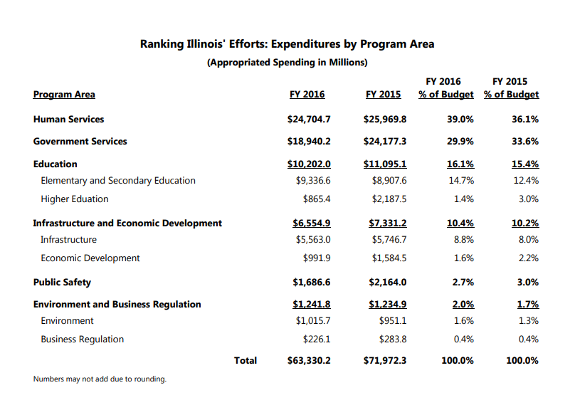***Fiscal Year Report***

|  |  |
| --- | --- |
| **Report/Program ID** | N/A |
| **Report/Program Title** | *Fiscal Year Report* |
| **Object Type** | *SSRS Report* |
| **New/Update** | *New Program* |
| **Inputs** | *FY* |
| **Outputs** | * Program Area * Program Area Group   For Selected Fiscal Year and the Prior Fiscal Year   * Program Area Expenditures * Program Area Group Expenditures * Program Area Percent of Budget * Program Area Group Percent of Budget |
| **Sort Order: A = Ascending**  **D = Descending** | *Descending*   * *Selected Fiscal Year’s Program Area Group Expenditures* |
| **Stored Procedure Called** | *PARFiscalYear* |
| **Selection Criteria** | *N/A* |
| **Report Description** | *Displays the total expenditures for each Program Area and Program Area Group and their percentage of budget.* |
| **Program Instructions** | *Report is grouped by Program Area Group ID* |
| **Business Rule** | *The user will be able to export the Fiscal Year Report to either Excel or PDF if only Fiscal Year is selected* |

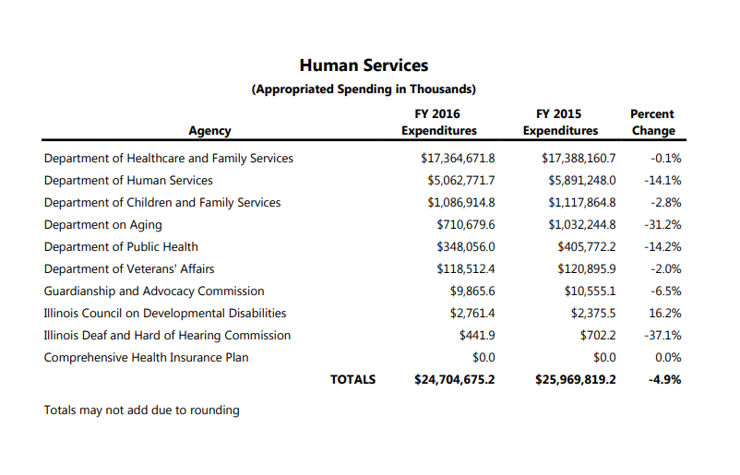***Program Area Report***

|  |  |
| --- | --- |
| **Report/Program ID** | N/A |
| **Report/Program Title** | *Program Area Report* |
| **Object Type** | *SSRS Report* |
| **New/Update** | *New Program* |
| **Inputs** | *FY, ProgramAreaGroupID* |
| **Outputs** | * Agency * Selected Fiscal Year Expenditures * Prior Fiscal Year Expenditures * Percent change |
| **Sort Order: A = Ascending**  **D = Descending** | *Descending*   * *Selected Fiscal Year’s Agency Expenditures* |
| **Stored Procedure Called** | *ProgramAreaReport* |
| **Selection Criteria** | *N/A* |
| **Report Description** | *Displays the total expenditures for selected and prior fiscal year for each Agency and displays the percent change between the two.* |
| **Program Instructions** | *Report is grouped by sub program area id if not null.* |
| **Business Rule** | *The user will be able to export the Program Area Report to either Excel or PDF if a Fiscal Year and a Program Area is selected.* |

***Agency Report***

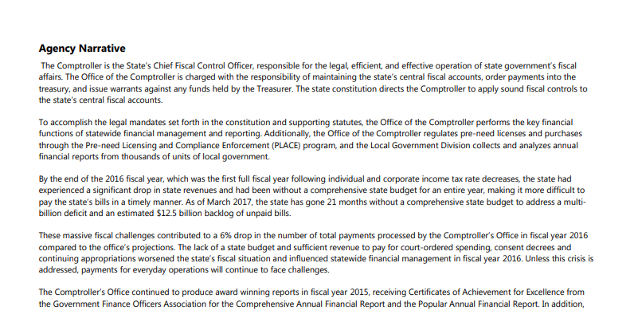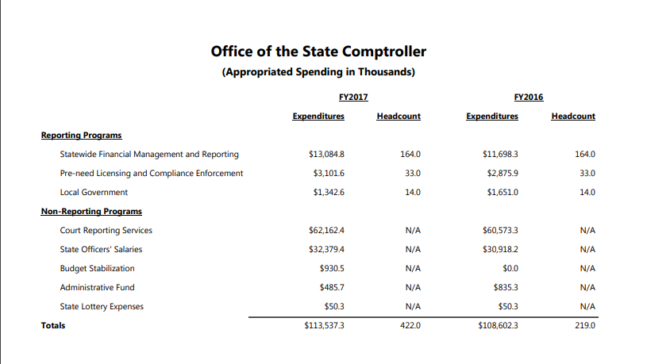

|  |  |
| --- | --- |
| **Report/Program ID** | N/A |
| **Report/Program Title** | *Agency Report* |
| **Object Type** | *SSRS Report* |
| **New/Update** | *New Program* |
| **Inputs** | *FY, AgencyNo* |
| **Outputs** | * Reporting Programs * Non-Reporting Programs * Agency Narrative   For Selected Fiscal Year and the Prior Fiscal Year   * Expenditures * Headcounts |
| **Sort Order: A = Ascending**  **D = Descending** | *Descending*   * *Reporting Program Expenditures* * *Non-Reporting Program Expenditures* |
| **Stored Procedure Called** | * *showProgramResource,* * *showAgency* |
| **Selection Criteria** | *N/A* |
| **Report Description** | *Displays the total expenditures and headcounts for selected and prior fiscal year for each program.* |
| **Program Instructions** | *Report is grouped by Reporting and Non-Reporting* |
| **Business Rule** | *The user will be able to export the Agency Report to either Excel or PDF if a Fiscal Year, a Program Area, and an Agency is selected.* |

***Program Report***

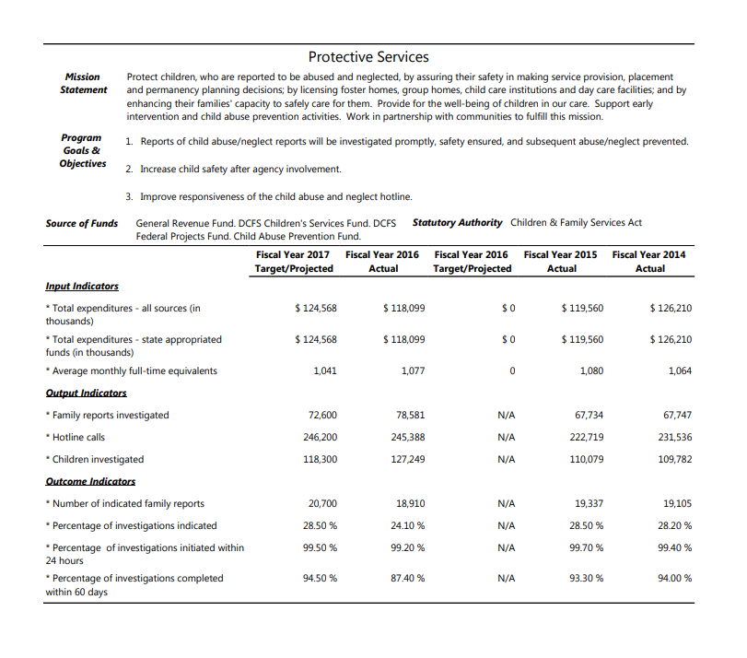

|  |  |
| --- | --- |
| **Report/Program ID** | N/A |
| **Report/Program Title** | *Program Report* |
| **Object Type** | *SSRS Report* |
| **New/Update** | *New Program* |
| **Inputs** | *FY, AgencyNo, ProgramID* |
| **Outputs** | * Mission Statement * Program Goals & Objectives * Source of Funds * Statutory Authority   For next year projected, selected year actual, selected year project, and the prior two years   * Input Indicators * Output Indicators * Outcome Indicators * External Benchmarks * Efficiency/ Cost-Effectiveness Indicators |
| **Sort Order: A = Ascending**  **D = Descending** | *Sorted by indicator type* |
| **Stored Procedure Called** | * *ProgramIndicators* * *GetPrograms* * *GetGoalsAndObjectives* * *GetSSRSFundNum2* * *GetFootnote* |
| **Selection Criteria** | *N/A* |
| **Report Description** | *Displays all the program’s indicators and their significant statistics.* |
| **Program Instructions** | *Report is grouped by indicator type* |
| **Business Rule** | *The user will be able to export the Program Report to either Excel or PDF if a Fiscal Year, a Program Area, an Agency and a Program is selected.* |

***Tables/View***

*This section identifies all table/view changes, which are required within the application. The following table should be filled out, if applicable:*

**Database Name: PAR Table Name: ProgramAreaGroups Database Type: SQL Server**

|  |  |  |  |  |  |
| --- | --- | --- | --- | --- | --- |
| **Field Name** | **Key/ Result** | **Data Type** | **Length** | **Required** | **Comments** |
| *ProgramAreaGroupID* |  | *Int* |  | *Yes* |  |
| *Description* |  | *Varchar* | *250* | *No* | *Not Required by Database, but by App* |

**Database Name: PAR Table Name: programAreas Database Type: SQL Server**

|  |  |  |  |  |  |
| --- | --- | --- | --- | --- | --- |
| **Field Name** | **Key/ Result** | **Data Type** | **Length** | **Required** | **Comments** |
| *ProgramAreaID* |  | *Int* |  | *Yes* |  |
| *Description* |  | *Varchar* | *250* | *No* | *Not Required by Database, but by App* |
| *ProgramAreaGroupID* |  | *Int* |  | *Yes* |  |

**Database Name: PAR Table Name: subProgramAreas Database Type: SQL Server**

|  |  |  |  |  |  |
| --- | --- | --- | --- | --- | --- |
| **Field Name** | **Key/ Result** | **Data Type** | **Length** | **Required** | **Comments** |
| *subPAID* |  | *Int* |  | *Yes* |  |
| *Description* |  | *Varchar* | *250* | *No* | *Not Required by Database, but by App* |
| *ProgramAreaID* |  | *Int* |  | *Yes* |  |

**Database Name: PAR Table Name: agencyProgramAreas Database Type: SQL Server**

|  |  |  |  |  |  |
| --- | --- | --- | --- | --- | --- |
| **Field Name** | **Key/ Result** | **Data Type** | **Length** | **Required** | **Comments** |
| *Agency_No* |  | *Int* |  | *Yes* |  |
| *ProgramAreaGroupID* |  | *Int* |  | *Yes* |  |
| *ProgramAreaID* |  | *Int* |  | *Yes* |  |
| *SubPAID* |  | *Int* |  | *No* |  |
| *FY* |  | *Int* |  | *Yes* |  |

## Policy and Procedure Considerations

*This section identifies policy and procedure changes.*

## System Location

*This section identifies where the system will reside (i.e. on the ioc-web-dept server under the Web App/Prod/html/AFR/directory).*

## Backup

*This section identifies the frequency and who will backup the system (i.e. Backups are done on a nightly basis by the Network section of the Information Technology Department).*

## OBDC Connections

*This section identifies the Server OBDC connections required and the individual user’s PC OBDC connections required.*

## Security Considerations

* *This section identifies the security of the application and any impacts to Security Administration.*
* *This section identifies any encryption requirements associated with the modification.*

## Warehouse Considerations

*This section identifies any warehouse requirements.*

## Conversion Requirements

*This section identifies any conversion requirements associated with the modification.*

## Documentation Changes

*This section identifies any changes that are required to the documentation.*

## Suggested Unit Test Cases

*This section identifies all the test cases that the programmer should perform as part of their testing.*

## Miscellaneous

*To retrieve Program Area information per Agency, additional database tables are required. The following describe new tables in the PAR database in to retrieve Program Area Group, Program Area, and Sub-Program Area information.*

|  |  |
| --- | --- |
| ***ProgramAreaGroupID – INT Primary Key*** | ***Description VARCHAR(250)*** |
| 1 | Human Resources |
| 2 | Government Services |
| 3 | Education |
| 4 | Infrastructure and Economic Development |
| 5 | Public Safety |
| 6 | Environment and Business Regulation |

|  |  |  |
| --- | --- | --- |
| ***ProgramAreaID – INT Primary Key*** | ***Description VARCHAR(250)*** | ***ProgramAreaGroupID – INT*** |
| 1 | Human Resources | 1 |
| 2 | Government Services | 2 |
| 3 | Elementary and Secondary Education | 3 |
| 4 | Higher Education | 3 |
| 5 | Infrastructure | 4 |
| 6 | Economic Development | 4 |
| 7 | Public Safety | 5 |
| 8 | Environment | 6 |
| 9 | Business Regulation | 6 |

|  |  |  |
| --- | --- | --- |
| ***SubProgramAreaID – INT Primary Key*** | ***Description VARCHAR(250)*** | ***ProgramAreaID*** |
| 101 | Executive Branch | 2 |
| 102 | Judicial Branch | 2 |
| 103 | Legislative Branch | 2 |
| 104 | Retirement Systems | 2 |
| 105 | Legislative Support Branch | 2 |

|  |  |  |  |  |
| --- | --- | --- | --- | --- |
| ***AgencyProgramArea*** | | | | |
| ***Agency_No – INT Primary Key*** | ***ProgramAreaGroupID*** | ***ProgramAreaID*** | ***SubProgramID*** | ***FY*** |
| 102 | 2 | 2 | 103 | 2017 |
| 103 | 2 | 2 | 103 | 2017 |
| 105 | 2 | 2 | 103 | 2017 |
| 108 | 2 | 2 | 103 | 2017 |
| 109 | 2 | 2 | 103 | 2017 |